Name=Perera T.P.G.S

Student ID- IT24103493

Module- PS

Exercise

1. A vending machine owner claims that customers choose the four snack types (A, B, C, D) with equal probability. To test this claim, a researcher records the number of purchases for each snack type during one week and results are given below

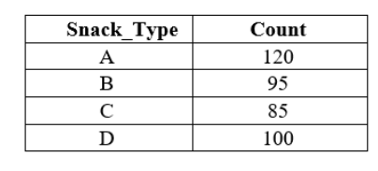

1. State the null and alternative hypotheses for the test.



1. Perform a suitable chi-squared test to test the null hypothesis.

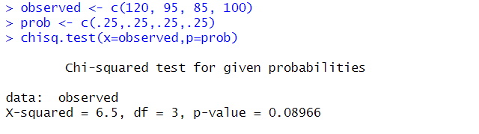

1. Give your conclusions based on the results.

